**COMSATS UNIVERSITY**



**SUBMITTED BY**

**Name: M.AHMAD QAMMAR**

**M. EHTASHAM-UL-HASSAN**

**M.MOAAZ MURTAZA**

**Registration No: FA20-BSE-071**

**FA20-BSE-080**

**FA20-BSE-084**

**Class/Section: BSE-5 (B)**

**SUBMITTED TO**

**Course Instructor: Sir Wasif Nisar**

**Course No: CSC 302**

**Course: Software Quality Engineering**

**Date: 14/11/2022**

**Contents:**

1. **FUNCTIONAL REQUIREMENTS**
2. **NON-FUNCTIONAL REQUIREMENTS**
3. **USE CASES AND ACTORS**
4. **FULLY DRESSED USE CASES**
5. **USE CASE DIAGRAM**
6. **CLASS DIAGRAM**

**Functional Requirements**

**Multiple Projects Storage**

This function has the capability to store multiple projects. And has high priority in this System.

**Assigning Projects**

Assigning projects is an important feature. This includes assigning the project to the relevant agency employee. This assigns the project to the. And has high priority in the system.

**Tracking Project**

Keeping the track of project deadlines is one of the major goals this management system aims to establish. The feature will keep the track of deadlines of projects once the projects are assigned to them.

**Prioritizing Projects**

Prioritizing is a necessity for freelancers to maximize their efficiency and productivity. Some projects are time sensitive. But in some project’s deadlines can be exceeded. This feature aims to assist employees with prioritizing projects as per their timelines and necessity and track them to work on them accordingly.

**Project Status**

This feature determines the conditional status of the project. In some cases, a project might be assigned to more than one employee or in normal cases too, status of the project has to be there for both agency managers and clients to be aware of their projects.

**Client Feedback**

Clients will be able to leave feedback after the project is marked as Completed. The feedback option becomes available only for clients. This feature aims to distinct employees of the agency based on their actual performances based on the reviews and ratings given by clients.

**Non-functional Requirements**

**Performance Requirements**

* Organizational and time management skills.
* Interpersonal and communication skills.
* Educational qualification.
* Equipment needed to complete task.

**Safety and Security Requirement**

This feature ensures that the system is protected from intrusions and that user data is safeguarded from theft or unauthorized manipulations.

list of the major security requirements is:

* Password management, the user can login after matching his email address and password.
* Data validation.
* The Manager can delete any user.
* Wrong id/password is allowed only for 3 times.

**Software Quality Attributes**

Updates or modification will be made on this project to improve the Quality.

**Use Case and Actors**

**Number of Actors: 03**

1. Manager
2. Client
3. Employee

**Total Number of Use Cases: 7**

**Use Cases:**

1. Registration of employee accounts.
2. Login System.
3. Project Assigning.
4. Project priority assigning.
5. Project deadline and Status assigning and checking.
6. Client access and information access.
7. Client feedback.

**Fully Dressed Use Cases**

|  |  |
| --- | --- |
| **Use Case ID** | **01** |
| Use Case | Employee Registration |
| Description | The manager of the agency registers for new employees of the agency and gives them their assigned credentials respectively. |
| Pre-condition | Employees will not be able to access the system or log in into it. |
| Post-condition | Employees will be able to login via the credentials provided to them. |
| Exception | General processing error. |

|  |  |
| --- | --- |
| **Use Case ID** | **02** |
| Use Case | Login System |
| Description | The manager and employees of the agency will be able to login with provided credentials. |
| Pre-condition | Actors will not have access to the software system. |
| Post-condition | Actors will be able to access the software system and use it’s functionalities. |
| Exception | General processing error, Invalid Credentials error. |

|  |  |
| --- | --- |
| **Use Case ID** | **03** |
| Use Case | Project Assigning |
| Description | The manager will enter the project into the database, and it will be assigned to an employee. |
| Pre-condition | The project will not be existent inside the system. |
| Post-condition | System will start tracking the project and showing it on the relevant employee’s dashboard. |
| Exception | General processing error |

|  |  |
| --- | --- |
| **Use Case ID** | **04** |
| Use Case | Project Priority Assigning |
| Description | One of the three priorities will be assigned to the project or changed if assigned earlier. |
| Pre-condition | The project will have initially assigned priority or no priority at all. |
| Post-condition | The project will be arranged on the dashboard as per it’s priority. |
| Exception | General processing error |

|  |  |
| --- | --- |
| **Use Case ID** | **05** |
| Use Case | Status checker |
| Description | Employee updates deadlines and status which is checked by client. |
| Pre-condition | The project will have the previously or initially defined status. |
| Post-condition | System will update the project Status |
| Exception | General error |

|  |  |
| --- | --- |
| **Use Case ID** | **06** |
| Use Case | Access client |
| Description | Client accesses software system with client ID and project ID that was assigned by the system earlier. |
| Pre-condition | Client can access the software through log in ID |
| Post-condition | Client can see the software |
| Exception | Invalid ID |

|  |  |
| --- | --- |
| **Use Case ID** | **07** |
| Use Case | Client Feedback |
| Description | Client gives feedback to respective employee through software. This improves the developer profile. |
| Pre-condition | Complete project will be awaiting feedback. |
| Post-condition | Rating and review will be assigned to employee |
| Exception | Invalid entries as rating will generate an error, general processing error |

**Use Case Diagram**

For this Use case diagram, we use tool **MS Visio**.

**Class Diagram**

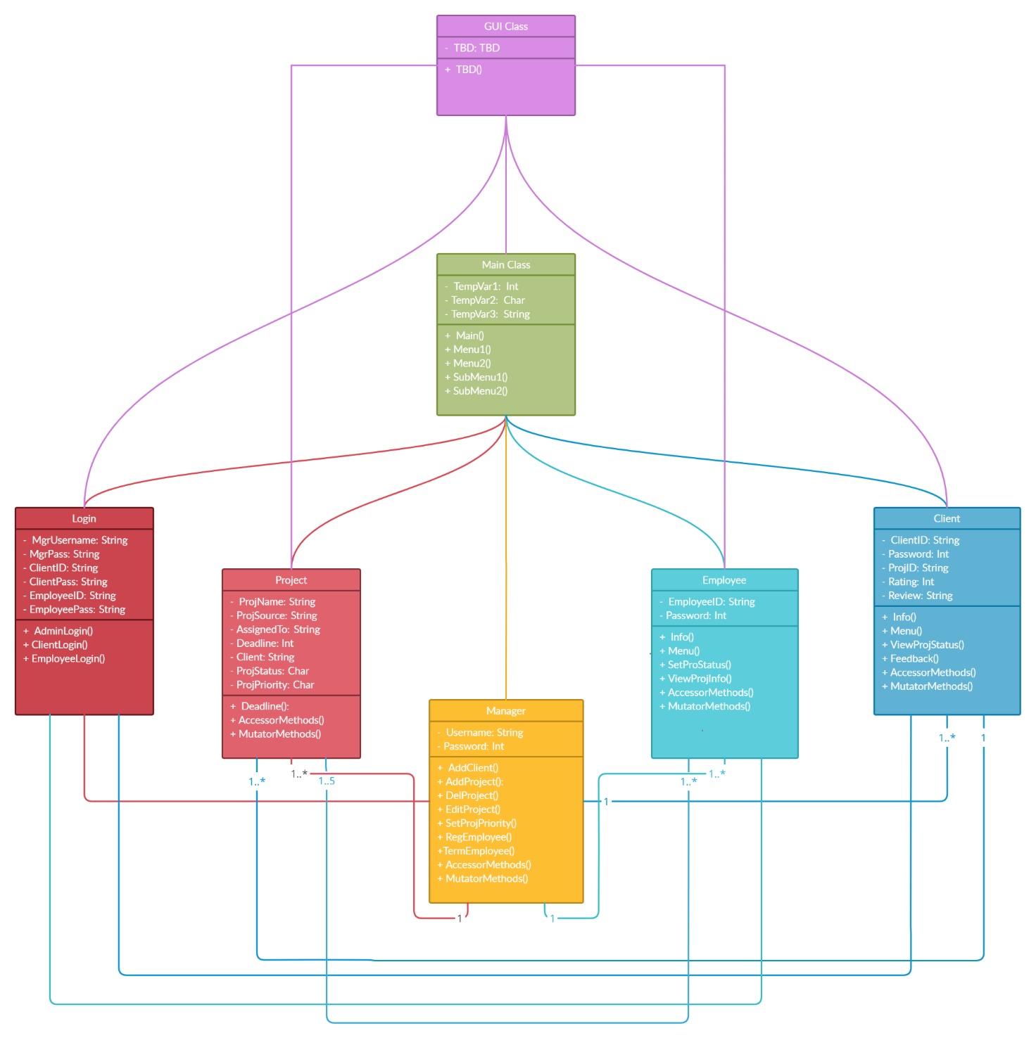

For this class diagram, we use online tool **creately.com.**